
Name: ________________

Year 8 Science 2018 M/C mark: ____ 10 Marks
Written: ____ 20 Marks
Physics 2 Test: Heat
TOTAL: ________ 30 MARKS

SECTION 1: MULTIPLE CHOICE (1 mark each)
Circle your answer on the multiple choice answer sheet on page 3.

- Which of the following is a type of potential energy?
  - mechanical
  - light
  - chemical
  - heat

- Which of these is not a method of heat transfer?
  - convection
  - conduction
  - radiation
  - insulation

- Which of the following is the most effective heat insulator?
- metal
- wood
- air
- a vacuum

- A material which easily allows heat to move through it is called
- an insulator.
- a conductor.
- a resistor.
- a circuit.

- When heat radiation hits a transparent surface such as glass, it may travel straight through, as shown in the diagram below.
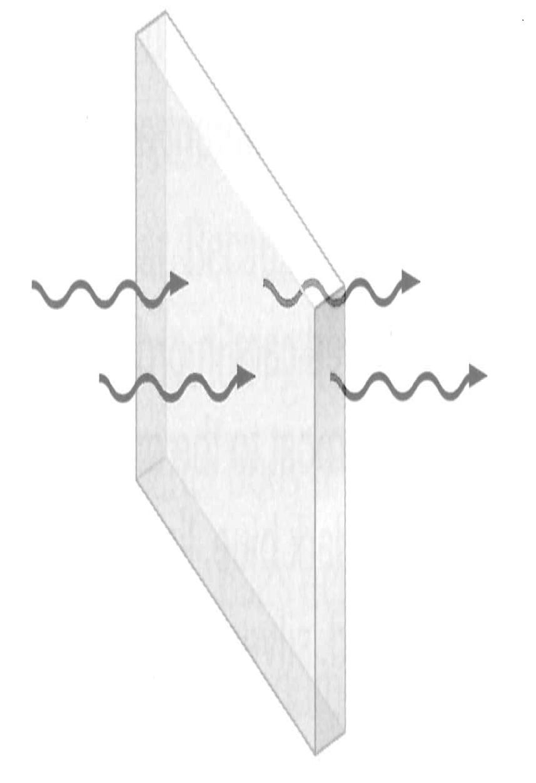
This is called
- transmission
- reflection
- absorption
- refraction

- Heat waves are a form of electromagnetic radiation and can also be called
- gamma rays
- X-rays
- ultraviolet
- infra red

- Which type of surface tends to be a good heat absorber?
- dull and dark
- shiny and light
- sparkly and colourful
- transparent

- Which of these is an adaptation to prevent heat loss?
- sweating
- goose bumps
- becoming flushed
- large ears or fins

- Most of the heat energy lost from a house in winter is lost through the
- floor.
- roof.
- windows.
- doors.

- The Coolgardie safe was invented during the 1890s gold rush to keep store cold food. It cools because of
- insulation.
- radiation.
- evaporation.
- conduction.

Section 1: Multiple Choice Answer Sheet

Circle your answers for the multiple choice section:

1: A B C D

2: A B C D

3: A B C D

4: A B C D

5: A B C D

6: A B C D

7: A B C D

8: A B C D

9: A B C D

10: A B C D

TOTAL MARK FOR M/C: _____ /10 MARKS
SECTION 2: WRITTEN
Write your answers on the lined paper provided.

- Explain each of the following, using correct terminology to describe energy transfers:

- Saucepans have plastic handles.

___________________________________________________

___________________________________________________ (2 marks)

- Putting a metal skewer into a potato will make it bake quicker.

___________________________________________________

___________________________________________________ (2 marks)

- It is warmer to wear two thin jumpers than one thick one.

___________________________________________________

___________________________________________________ (2 marks)

- Explain the difference between heat and temperature.

___________________________________________________

___________________________________________________

___________________________________________________ (2 marks)

- The diagram below shows conduction, convection and radiation.

Explain how well each of these methods occur in solids, liquids, gases and space.

Solids: _______________________________________________

_____________________________________________________ (2 marks)

Liquids: ______________________________________________

_____________________________________________________ (2 marks)

Gases: _______________________________________________

_____________________________________________________ (2 marks)

Space (Vacuum – no air) _________________________________

_____________________________________________________ (2 marks)

- Draw a labelled diagram to show how a convection/oil heater is used to heat a cold room and warm the person sitting at the desk. Explain within the diagram what is occurring and why.

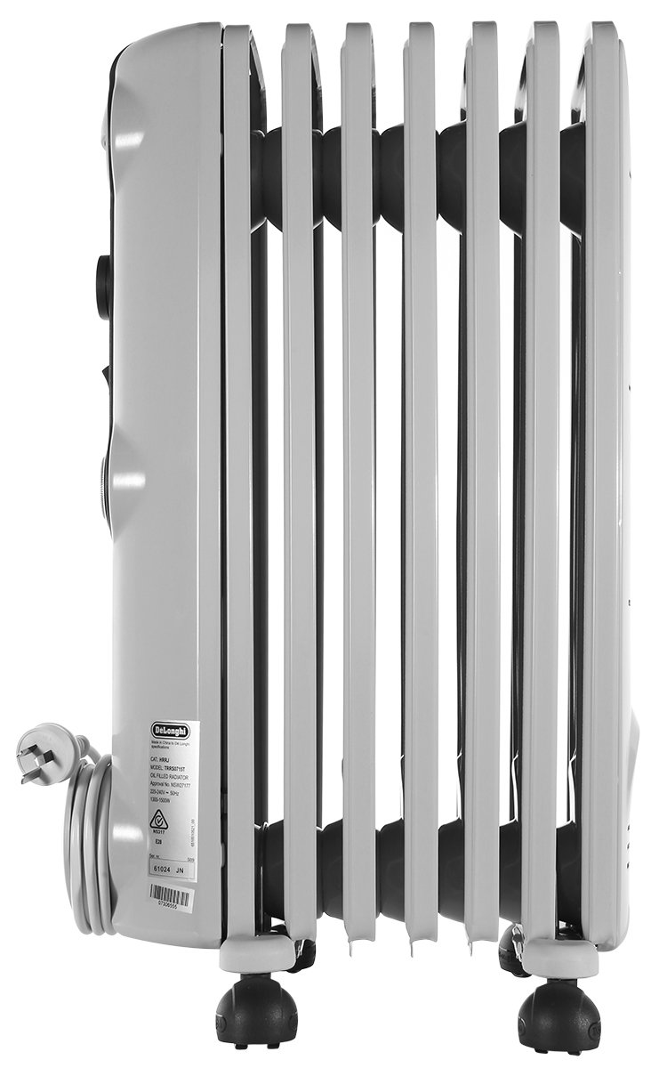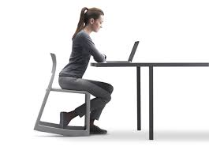

(4 marks)

END OF TEST (OUT OF 30 MARKS)

